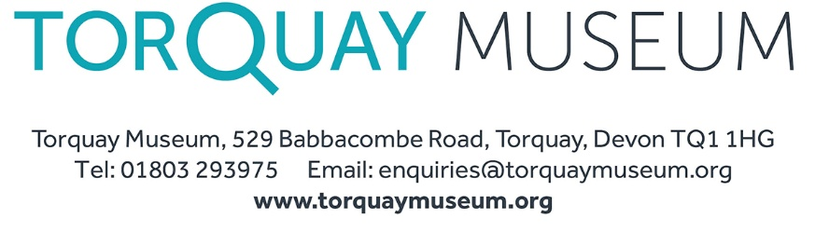

**Job Title: Collections Assistant**

**Location:** Torquay Museum, Torquay, Devon  
**Contract Type:** Part-time – 4 days per week / Fixed-term for 12 Months  
**Reports to:** Collections and Operations Manager

**About Torquay Museum**

Torquay Museum is an independent museum founded in 1845, housing more than 300,000 items of regional, national, and international significance. The Museum plays a vital role in preserving and interpreting the cultural and natural heritage of Torbay and is a key partner in the English Riviera UNESCO Global Geopark.

**Role Purpose**

The Collections Assistant supports the care, documentation, and accessibility of the Museum’s diverse collections. This role is essential to maintaining high standards of collections management and contributing to the Museum’s strategic goals, including those outlined in the current projects funded by the National Lottery Heritage Fund.

**Key Responsibilities**

* Assist with the documentation, cataloguing, and digitisation of collection items.
* Support the preservation and conservation of objects, including environmental monitoring and handling procedures.
* Help maintain accurate records in the collections management system.
* Participate in collection audits and inventories.
* Assist with research enquiries and provide access to collections for staff, researchers, and the public.
* Support exhibition preparation, including object locating, condition reporting, installation and general movement of items in and out of museum stores and galleries.
* Contribute to the ongoing development of policies and procedures related to collections care.
* Collaborate with other staff on audience engagement and educational initiatives.
* Creation of social media posts relating to your area of work.
* Provide support for the Museum’s strategic projects, including the objectives for the two NLHF projects and requirements for accreditation.
* Assist with any other duties as reasonably determined by the management of the museum.

**Person Specification**

**Essential:**

• A Degree-level qualification in a relevant subject or equivalent experience.

• Experience of working with and handling museum objects and/or archives through work, research, study and/or volunteering.

• Good IT skills, including familiarity with databases and Microsoft Office.

• Strong communication skills both in person and in writing.

• Willingness to work collaboratively.

• Ability to work independently and to take initiative when needed.

• Willingness to undertake physical tasks, including lifting and moving objects safely.

**Desirable**:

• Experience of working with and supervising volunteers.

• Familiarity with environmental monitoring and preventative conservation.

• Experience using a collections management system (MODES in particular).

• An understanding of Spectrum Standards.

**Additional Information**

* Training will be provided where necessary.
* The role will involve weekend and occasional evening work.
* This position contributes directly to the Museum’s mission to safeguard and interpret its collections for public benefit.
* All employees are expected to work within the terms of their contract of employment, adhere to the Museum’s Policies, Values and Behaviours, and to follow the Museums Association’s *Code of Ethics*.